Calculate the total amount, after n years:

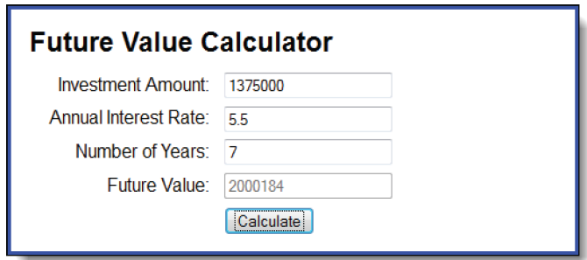

Suggestions :

1. Structure code

Window.onload = function() {  
 element_object_assign_event.name_event = function(){

// 1. Get value from form_input

// 2. Check value input

// 3. Caculate (Sugges : Follow 3.1)

// 4. Set value for input Future_Value (Sugges : Follow 4.1)

}  
}

* 1. Caculate Future value :

First year :

Investment_Amount + Investment_Amount * Rate

Second year :

Investment_Amount + Investment_Amount * Rate

+ (Investment_Amount + Investment_Amount * Rate) * Rate

N(th) year :

The_Total_Of_The_Previous_Year + The_Total_Of_The_Previous_Year * N(year)

4.1 Set value for input : $(“id_element”).value = value_caculate